Chapter 31
International Corporate Finance
31-1. You are a U.S. investor who is trying to calculate the present value of a €5 million cash inflow that will occur one year in the future. The spot exchange rate is S = $1.25/€ and the forward rate is F₁ = $1.215/€. You estimate that the appropriate dollar discount rate for this cash flow is 4% and the appropriate euro discount rate is 7%.
a. What is the present value of the €5 million cash inflow computed by first discounting the euro and then converting it into dollars?
b. What is the present value of the €5 million cash inflow computed by first converting the cash flow into dollars and then discounting?
c. What can you conclude about whether these markets are internationally integrated, based on your answers to parts (a) and (b)?
a. 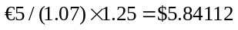 million
b. 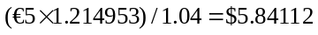 million
c. Yes, the markets are internationally integrated because the answers to (a) and (b) are identical.
31-2. Mia Caruso Enterprises, a U.S. manufacturer of children’s toys, has made a sale in Cyprus and is expecting a C£4 million cash inflow in one year. The current spot rate is S = $1.80/C£ and the one-year forward rate is F₁ = $1.8857/C£.
a. What is the present value of Mia Caruso’s C£4 million inflow computed by first discounting the cash flow at the appropriate Cypriot pound discount rate of 5%, and then converting the result into dollars?
b. What is the present value of Mia Caruso’s C£4 million inflow computed by first converting the cash flow into dollars, and then discounting at the appropriate dollar discount rate of 10%?
c. What can you conclude about whether these markets are internationally integrated, based on your answers to parts a and b?
a. 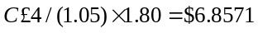 million
b. 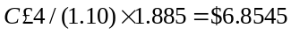 million
c. No, the markets are not internationally integrated because the answers to (a) and (b) are not the same.

31-3. Etemadi Amalgamated, a U.S. manufacturing firm, is considering a new project in the euro area. You are in Etemadi’s corporate finance department and are responsible for deciding whether to undertake the project. The expected free cash flows, in euros, are shown here:
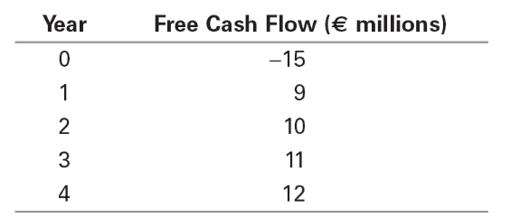
You know that the spot exchange rate is S = $1.15/€. In addition, the risk-free interest rate on dollars is 4% and the risk-free interest rate on euros is 6%.
Assume that these markets are internationally integrated and the uncertainty in the free cash flows is not correlated with uncertainty in the exchange rate. You determine that the dollar WACC for these cash flows is 8.5%. What is the dollar present value of the project? Should Etemadi Amalgamated undertake the project?
First, calculate the forward rates:
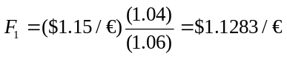
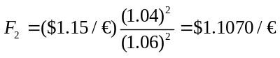
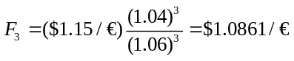
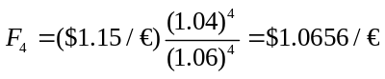
Next, convert euro cash flows into dollars:

Year | Euro Cash Flow | Exchange Rate | Dollar Cash Flow
0 | –15 | 1.1500 | –17.250
1 | 9 | 1.1283 | 10.155
2 | 10 | 1.1070 | 11.070
3 | 11 | 1.0861 | 11.947
4 | 12 | 1.0656 | 12.788

Finally, the net present value is:
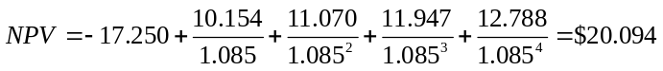 million.
Etemadi Amalgamated should undertake the project because the net present value is positive.
31-4. Etemadi Amalgamated, the U.S. manufacturing company in Problem 3, is still considering a new project in the euro area. All information presented in Problem 3 is still accurate, except the spot rate is now S = $0.85/€, about 26% lower. What is the new present value of the project in dollars? Should Etemadi Amalgamated undertake the project?
With the 26% drop in the spot rate, the forward rates need to be recalculated:
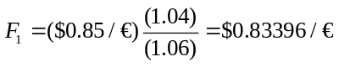
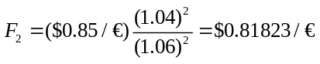
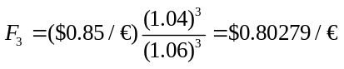
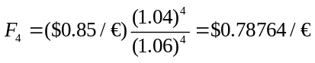
Next, euro cash flows are reconverted into dollars:

Year | Euro Cash Flow | Exchange Rate | Dollar Cash Flow
0 | –15 | 0.85000 | –12.750
1 | 9 | 0.83396 | 7.506
2 | 10 | 0.81823 | 8.182
3 | 11 | 0.80279 | 8.831
4 | 12 | 0.78764 | 9.452

Finally, the net present value is:
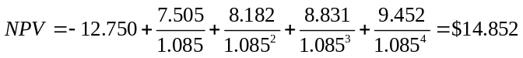 million.
Etemadi Amalgamated should still undertake the project because the net present value is positive. Note that this is 26% lower than the answer in 31-5, which is consistent with the 26% drop in the spot exchange rate.
31-5. You work for a U.S. firm, and your boss has asked you to estimate the cost of capital for countries using the euro. You know that S = $1.20/€ and F₁ = $1.157/€. Suppose the dollar WACC for your company is known to be 8%. If these markets are internationally integrated, estimate the euro cost of capital for a project with free cash flows that are uncorrelated with spot exchange rates. Assume the firm pays the same tax rate no matter where the cash flows are earned.
The Law of One Price tells us: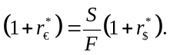
As a result, we have: 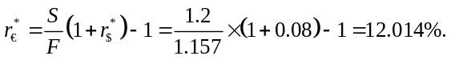
31-6. Maryland Light, a U.S. light fixtures manufacturer, is considering an investment in Japan. The dollar cost of equity for Maryland Light is 11%. You are in the corporate treasury department, and you need to know the comparable cost of equity in Japanese yen for a project with free cash flows that are uncorrelated with spot exchange rates. The risk-free interest rates on dollars and yen are r$ = 5% and r¥ = 1%, respectively. Maryland Light is willing to assume that capital markets are internationally integrated. What is the yen cost of equity?
Using the formula for the Internationalization of the Cost of Capital, we have: 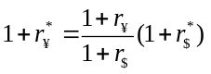.
As a result, we obtain:
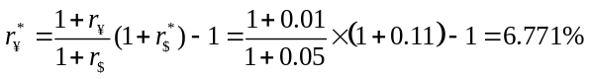.
31-7. The dollar cost of debt for Coval Consulting, a U.S. research firm, is 7.5%. The firm faces a tax rate of 30% on all income, no matter where it is earned. Managers in the firm need to know its yen cost of debt because they are considering launching a new bond issue in Tokyo to raise money for a new investment there. The risk-free interest rates on dollars and yen are r$ = 5% and r¥ = 1%, respectively. Coval Consulting is willing to assume that capital markets are internationally integrated and that its free cash flows are uncorrelated with the yen-dollar spot rate. What is Coval Consulting’s after-tax cost of debt in yen? (Hint : Start by finding the after-tax cost of debt in dollars and then find the yen equivalent.)
The after-tax cost of debt in dollars is (0.075)(1 – 0.30) = 0.0525 or 5.25%.
Using the formula for the Internationalization of the Cost of Capital, we have: .
As a result, we obtain:
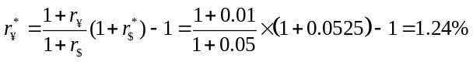.
31-8. Manzetti Foods, a U.S. food processing and distribution company, is considering an investment in the euro area. You are in Manzetti’s corporate finance department and are responsible for deciding whether to undertake the project. The expected free cash flows, in euros, are uncorrelated to the spot exchange rate and are shown here:
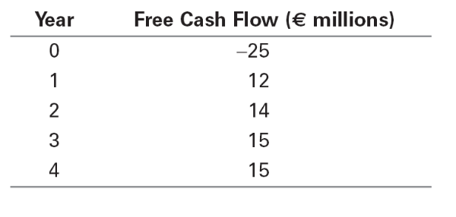
The new project has similar dollar risk to Manzetti’s other projects. The company knows that its overall dollar WACC is 9.5%, so it feels comfortable using this WACC for the project. The risk-free interest rate on dollars is 4.5% and the risk-free interest rate on euros is 7%.
a. Manzetti is willing to assume that capital markets in the United States and the euro area are internationally integrated. What is the company’s euro WACC?
b. What is the present value of the project in euros?
a. Using the formula for the Internationalization of the Cost of Capital, we have:
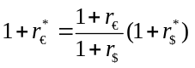.
As a result, we obtain:
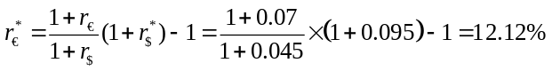.
b. 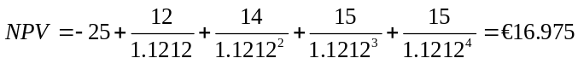million.
31-9. Tailor Johnson, a U.S. maker of fine menswear, has a subsidiary in Ethiopia. This year, the subsidiary reported and repatriated earnings before interest and taxes (EBIT) of 100 million Ethiopian birrs. The current exchange rate is 8 birr/$ or S1 = $0.125/birr. The Ethiopian tax rate on this activity is 25%. U.S. tax law requires Tailor Johnson to pay taxes on the Ethiopian earnings at the same rate as profits earned in the United States, which is currently 45%. However, the United States gives a full tax credit for foreign taxes paid up to the amount of the U.S. tax liability. What is Tailor Johnson’s U.S. tax liability on its Ethiopian subsidiary?
With earnings of 100 million birrs and the Ethiopian tax rate of 25%, the tax paid in Ethiopia is 25 million birrs. With an exchange rate of 0.125/birr, the earnings amount to $12.5 million and the Ethiopian taxes amount to $3.125 million. With a tax rate of 45%, the U.S. tax on Tailor Johnson’s Ethiopian income would be 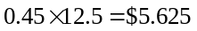 million. However, Tailor Johnson is able to claim a tax credit of $3.125, for a net tax liability of 5.625 – 3.125 = $2.5 million.
31-10. Tailor Johnson, the menswear company with a subsidiary in Ethiopia described in Problem 9, is considering the tax benefits resulting from deferring repatriation of the earnings from the subsidiary. Under U.S. tax law, the U.S. tax liability is not incurred until the profits are brought back home. Tailor Johnson reasonably expects to defer repatriation for 10 years, at which point the birr earnings will be converted into dollars at the prevailing spot rate, S₁₀, and the tax credit for Ethiopian taxes paid will still be converted at the exchange rate S₁ = $0.125/birr. Tailor Johnson’s after-tax cost of debt is 5%.
a. Suppose the exchange rate in 10 years is identical to this year’s exchange rate, so S₁₀ = $0.125/birr. What is the present value of deferring the U.S. tax liability on Tailor Johnson’s Ethiopian earnings for 10 years?
b. How will the exchange rate in 10 years affect the actual amount of the U.S. tax liability? Write an equation for the U.S. tax liability as a function of the exchange rate S10.
a. From question 31-9, the tax liability is $2.5 million. Deferred for 10 years, using the after-tax cost of debt at 5%, the present value is 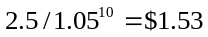million. Hence, the value of deferral is 2.5 – 1.53 = $0.97 million.
b. The earnings will need to be converted at the future exchange rate, 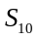, although the tax credit will still be calculated at 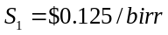. Hence, the U.S. tax liability will be 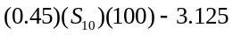.
31-11. Peripatetic Enterprises, a U.S. import-export trading firm, is considering its international tax situation. U.S. tax law requires U.S. corporations to pay taxes on their foreign earnings at the same rate as profits earned in the United States; this rate is currently 45%. However, a full tax credit is given for the foreign taxes paid up to the amount of the U.S. tax liability. Peripatetic has major operations in Poland, where the tax rate is 20%, and in Sweden, where the tax rate is 60%. The profits, which are fully and immediately repatriated, and foreign taxes paid for the current year are shown here:
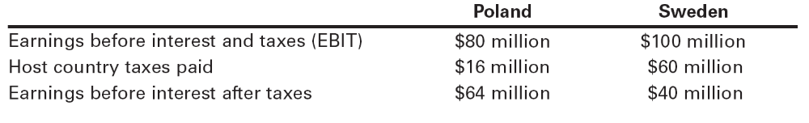
a. What is the U.S. tax liability on the earnings from the Polish subsidiary assuming the Swedish subsidiary did not exist?
b. What is the U.S. tax liability on the earnings from the Swedish subsidiary assuming the Polish subsidiary did not exist?
c. Under U.S. tax law, Peripatetic is able to pool the earnings from its operations in Poland and Sweden when computing its U.S. tax liability on foreign earnings. Total EBIT is thus $180 million and the total host country taxes paid is $76 million. What is the total U.S. tax liability on foreign earnings? Show how this relates to the answers in parts a and b.
a. The net U.S. tax liability, after claiming the credit for taxes paid in Poland, is 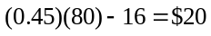million.
b. The net U.S. tax liability, after claiming the credit for taxes paid in Sweden, is 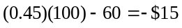million. However, the use of the tax credit is limited to the U.S. tax liability, so the liability is actually zero. This is an excess tax credit of $15 million that is lost.
c. Pooling the Polish and Swedish subsidiaries, the net U.S. tax liability is: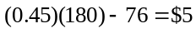 million. By pooling, Peripatetic Enterprises is able to use the $15 million excess tax credit from earnings in Sweden to offset $15 million of the $20 million net tax liability from earnings in Poland, leaving a net U.S. tax liability of $5 million.
31-12. Suppose the interest on Russian government bonds is 7.5%, and the current exchange rate is 28 rubles per dollar. If the forward exchange rate is 28.5 rubles per dollar, and the current U.S. risk-free interest rate is 4.5%, what is the implied credit spread for Russian government bonds?
From Eq 30.3 (covered interest parity), the forward and spot ruble/$ exchange rates satisfy:
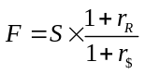
where and are risk-free interest rates in rubles and dollars respectively. With this equation we can use the spot and forward exchange rates, and the risk-free $ interest rate, to solve for the risk-free ruble interest rate:
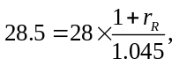 which implies 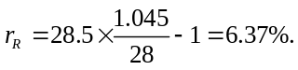
Therefore, the implied risk-free ruble interest rate is 6.37%, implying that Russian government bonds have an implied credit spread of 7.5% – 6.37% = 1.13% to compensate investors for the possibility of the Russian government defaulting.
(See example 31.3 for a similar problem. Note also that an investor can obtain a risk-free investment in rubles by exchange rubles for dollars at the spot rate of 28 rubles/$, investing in U.S. Treasuries at 4.5%, and locking in a forward exchange rate of 28.5 rubles/$ to convert the proceeds back to rubles. The rate computed above is the effective return from this transaction.)
31-13. Assume that in the original Ityesi example in Table 31.1, all sales actually occur in the United States and are projected to be $60 million per year for four years. Keeping other costs the same, calculate the NPV of the investment opportunity.
The solution to this problem is in the following Excel spreadsheet:
